Heru’s Happy Hero’s 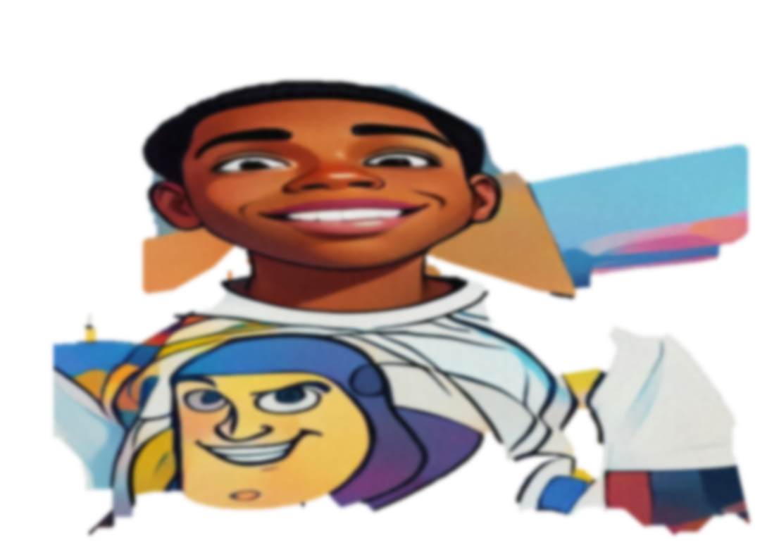

Autism’s Got Talent Show 2026
Calling all Autistic Hero’s to show case their talent
All talents welcomed: Dance, Singing, Classical Music, Art Work, Poetry, Musical Instruments, Rap Music, Theatre (Shakes Spear), Sporting Abilities and more!
All age groups welcomed!
For more information and to register your talent Please call 313-675-2263, Thasha Murphy

Date of event October 03, 2026

